SMS Subscribe
Users navigate to the /subscribe web page which can be accessed on the company intranet by employees.
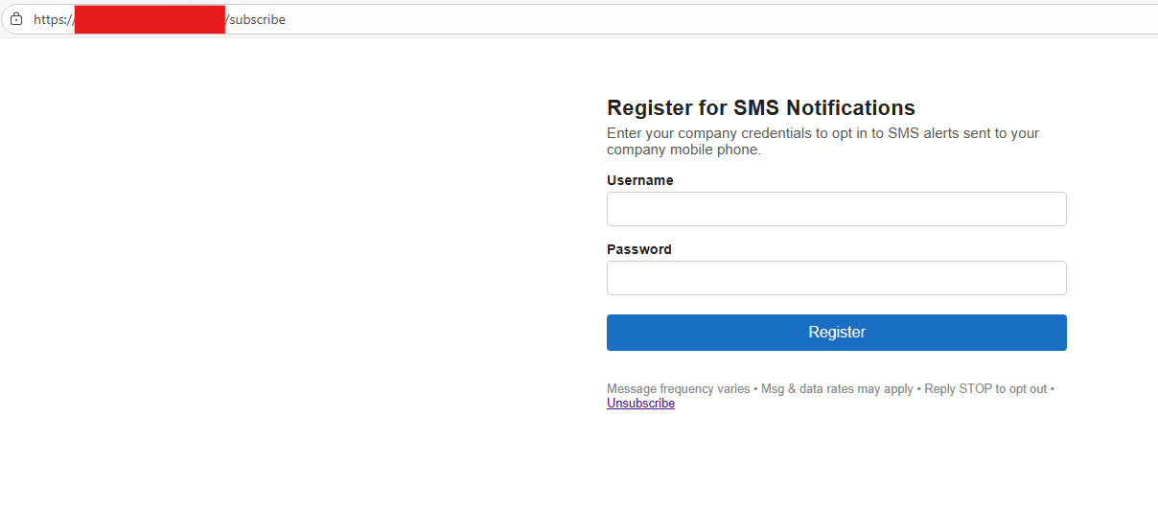
Users will enter their company credentials. The service will verify those credentials, look up the user in active directory and verify that the user has a mobile attribute. The mobile attribute contains the company issued phone number for the employee.
The database records the username, phone number, and date time of the subscription.
A welcome text message will be sent to the user’s phone upon registration.

SMS Unsubscribe
Users navigate to the /unsubscribe web page which can be accessed on the company intranet by employees.
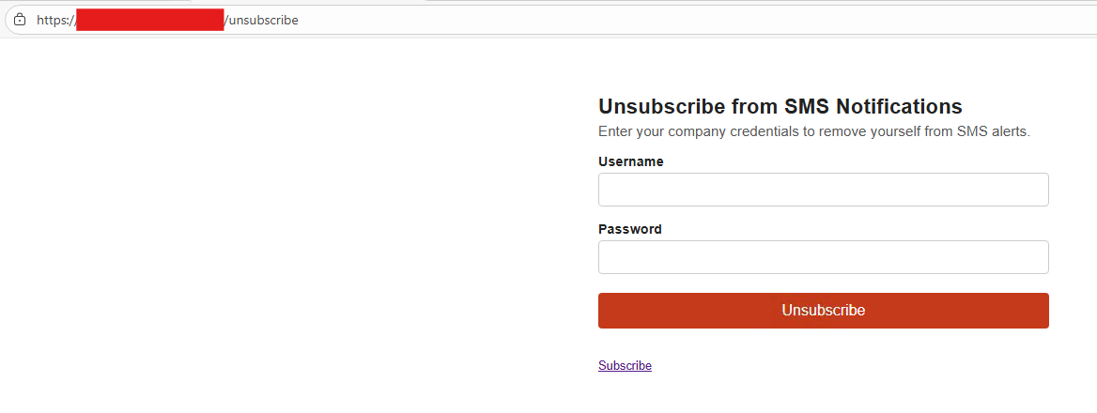
Users will enter their company credentials. The service will verify those credentials and then delete the user entry from the database to confirm that user has been unsubscribed.

